FOAM TILES Technology PRODUCT INTRODUCTION

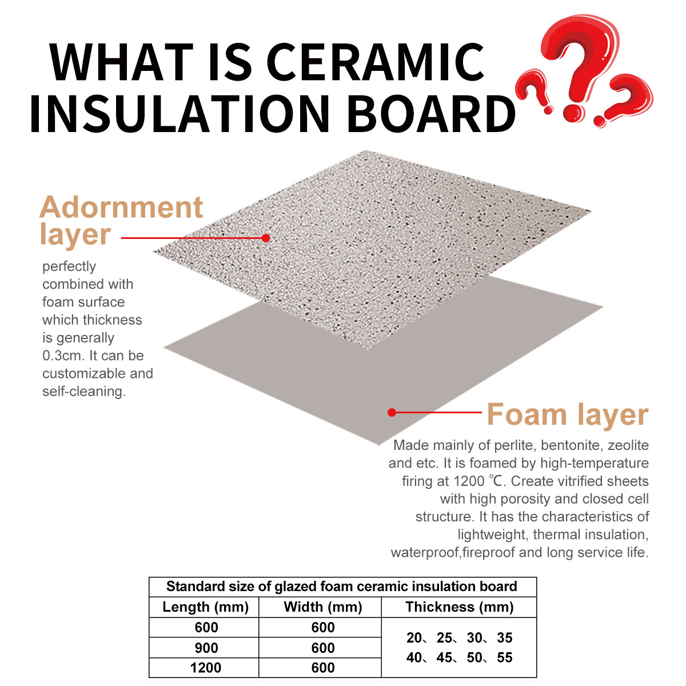

FOAM TILES IS NEW METRIAL FOR WATER PROOF AND FIRE PROOF, MOSTLY FOR POTECT HEAT AND COLD.We have obtained a patent for these products

This new metrial is creatived by our facotry, It composite by foam layer and adornment layer. Burning in 500 meter kilms at a high temperature of 1200 ℃ over 3 hours. The board has a low density and can float on the water surface. The board has the characteristics of lightweight,thermal insulation, waterproof and fireproof, moisture-proof and noise proof, inorganic environmental protection, acid and alkali resistance, wear and corrosion resistance, and long service life

According to our National Standards, all materials with a thermal conductivity coefficient not greater than 0.12 W/m.K ( Watts/meter. Kelvin degree ) at the acerage temperature of not higher than 35 C can be used as the thermal insulation materials, while our test report only 0.0638, means our products have excellent warm and cold preservation effect

Adornment layer Perfectly combined with foam surface, the thickness is generally 0.3cm, and the decorative styles are diverse and customizable. The rain curtain is self-cleaning.

Decorative layer: perfectly combined with the foam surface,with a thickness of generally 0.3cm, diverse surface colors and patterns, and strong self-cleaning ability.

Foaming layer: Made mainly of perlite,bentonite,zeolite,etc. it is foamed by high-temperature firing at 1200 ℃. Create vitrified sheets with high porosity and closed cell structure. Low density, can float on the water surface. It has the characteristics of lightweight, thermal insulation, waterproof and fireproof, moisture-proof and noise reduction, inorganic environmental protection, acid and alkali resistance, and long service life.

Product Features

Lightweight and high-strength, energy-saving and thermal insulation, waterproof and fireproof, acid and alkali resistant, sound insulation and noise reduction, moisture-proof and frost resistant, strong self-cleaning performance, longservice life, customizable patterns, etc; And the construction is convenient, the construction period is short, theadhesive anchor hanging technology is specialized, and it is safe and reliable.

Product Applications Scenarios

The product has various application scenarios, including shopping malls, schools, hospitals, residences, office buildings, villas, garages, swimming pools, underground passages, high-speed railway tunnels, cold storage rooms, and old city reconstructions. It is lightweight with a high safety factor, excellent heat insulation, customizable decorative surfaces, a long service life, and does not deform or age in sun and rain, having the same lifespan as the building.

Product Advantages Description

Inorganic environmentally friendly products are made by firing inorganic raw materials at a high temperature of 1200 ℃, which are green, non-toxic, zero emission, and radiation free. They make rational use of existing resources to turn waste into treasure.

Lightweight and high-strength products have a low self weight and high safety factor, weighing only one ninth of traditional stone slabs, reducing building loads, saving building structural costs, and making them easy to construct.

The closed cell structure with high porosity and energy-saving insulation has excellent insulation effect, greatly reducing heating and cooling energy consumption, saving energy expenditure, and achieving building energy conservation.

Waterproof, fireproof, high-temperature sintered fully closed cell structural vitrified products with extremely low water absorption rate, superior waterproof, moisture-proof, and mold proof performance, with A1 level combustion performance and fire retardant.

The product has a long service life and is based on ceramic mechanism. It has strong environmental adaptability, does not deform or age, and can have the same service life as buildings.

Texture can be customized. Fuou Technology now has the ability to develop original color palettes and can customize according to customers' different decoration styles.

The structural characteristics of sound insulation and noise reduction board with a high porosity of 60% make it have extremely strong sound insulation effect, which is superior to general walls

Construction technology of glazed foam ceramic insulation board

1. general provisions

1.1 The construction of glazed foam ceramic insulation board external wall insulation system should be carried out after the quality acceptance of the base construction is qualified, and the quality of the base should be inspected before construction.

1.2 The construction unit shall prepare a special construction plan, which shall be reviewed and approved by the supervision (construction) unit before implementation. Technical disclosure should be conducted before construction, and the construction personnel

Employees should undergo training.

1.3 Before the production and installation of glazed foam ceramic insulation boards, the layout design should be carried out based on the design documents and the actual dimensions of the wall surface.

1.4 Before the construction of the glazed foam ceramic insulation board external wall insulation system, a sample wall should be made on the base layer to be constructed and inspected to be qualified.

1.5 During the construction of glazed foam ceramic insulation board exterior wall insulation system, process control should be strengthened. Only after the acceptance of the previous process is qualified, can the next process be carried out.The concealed works and inspection batches should be inspected and accepted.

1.6 During the construction of the glazed foam ceramic insulation board external wall insulation system, the base and ambient air temperature should not be lower than 0 ℃, and the daily average temperature should not be lower than 5 ℃. Avoid direct sunlight exposure in summer. Construction shall not be carried out in windy weather above level 5, rainy or snowy weather. Rainproof measures should be taken during rainy season construction.

1.7 After the completion of the glazed foam ceramic insulation board external wall insulation system, the finished product protection should be done well.

1. Construction preparation

2.1 The surface of the base wall should be clean, solid, smooth, and free of attachments such as oil stains and release agents that hinder bonding. The quality of the base wall should comply with the current national standards such as the "Code for Acceptance of Construction Quality of Masonry Structures" GB50203 and the "Code for Acceptance of Construction Quality of Concrete Structures" GB50204.

2.2 When leveling the base wall, the allowable deviation of the surface flatness of the base after leveling is 3mm, and it should comply with the following regulations:

1 The outer side of the base wall is leveled with cement mortar, and the thickness of the leveling layer can be determined according to the flatness of the wall surface and should not exceed 20mm

2 When the base wall is made of concrete wall panels, concrete porous bricks, small hollow concrete blocks, gray sand bricks and other masonry materials, a concrete interface agent should be applied between the base wall and the cement mortar leveling layer

3 When the base wall is made of aerated concrete wall panels or aerated concrete block masonry, a thin layer of plastering mortar leveling layer should be applied after applying a special interface agent

2.3 The leveling layer should be firmly bonded to the base wall without delamination, hollowing, looseness, or cracking. The bonding strength between the leveling layer and the base wall should comply with the design and relevant standards

2.4 On site pull-out tests of anchor bolts should be conducted on the base wall, and the test results should meet the design requirements

2.5 Before the construction of the glazed foam ceramic insulation board external wall insulation system, the external door and window openings should pass the acceptance inspection. The size and position of the openings should meet the design and quality requirements, and the door and window frames or auxiliary frames should be installed completely.

2.6 The installation of downspouts, various pipelines, and embedded parts and connectors for air conditioners extending from the wall should be completed, and a construction gap with glazed foam ceramic insulation board for the external wall insulation system should be left

2.7 Construction operation platforms, scaffolding, and hanging baskets should be accepted and qualified

2.8 Glazed foam ceramic insulation boards should be stored in order of installation. Protective measures should be taken when storing outdoors

1. Construction technology and key points

3.1 The construction of glazed foam ceramic insulation board external wall insulation system should be carried out from bottom to top on each floor, starting with door and window openings and then the large wall surface, starting with external corners and then internal corners, and following the following procedures:

Grassroots inspection → measurement and setting out → drawing layout diagram, material preparation → configuring adhesive, determining anchor bolt position and drilling → pasting glazed foam ceramic insulation board → installing anchoring components → filling joint materials, constructing building sealant → cleaning the board surface

3.2 Measurement and laying out shall comply with the following regulations：

1.According to the technical requirements of the building facade design and the glazed foam ceramic insulation board external wall insulation system, vertical and horizontal control lines should be marked on the wall surface, and the actual dimensions of doors, windows, lines, and walls should be measured from the control lines

2.When dividing lines, vertical reference lines should be hung at the corners of the building's exterior walls and other necessary locations, and horizontal lines should be hung at appropriate positions on each floor. The installation control lines for each board should be marked according to the partition scheme in the design layout diagram, and the joint width should be determined. A uniform feeler gauge should also be made

3.3 The drawing of the layout diagram should comply with the following regulations：

1. Before measuring and setting out, the optimized layout plan should be determined based on the design drawings

2、After measuring and laying out, the layout design should be refined based on the actual situation of the line, and a list of actual dimensions and detailed construction drawings for each board should be provided.

3.4 The position of anchor bolt holes on the base wall should be determined based on measurement and corresponding installation positions of glazed foam ceramic insulation board corner codes. Anchor bolt holes should be constructed and cleaned before pasting glazed foam ceramic insulation boards.

3.5 The preparation and use of adhesives should comply with the following regulations：

1、It should be prepared according to the requirements of the material supplier's product manual.

2、The mixing time should not be less than 5 minutes after the completion of self feeding, and should be prepared according to the amount used during the operating time. After preparation, it should be used up according to the time specified in the product manual, and should be used up within 2 hours for summer construction

3.6 The pasting of glazed foam ceramic insulation board shall comply with the design requirements and the provisions of Articles 5.2.3 and 5.2.4 of this regulation, and shall meet the following requirements

1、Glazed foam ceramic insulation boards should be laid and pasted horizontally from bottom to top according to the pre arranged boards and numbers. The bottom edge of the first row of glazed foamed ceramic insulation board should be fixed with battens

2、After pasting, the surface flatness and verticality of the glazed foam ceramic insulation board should meet the requirements of this regulation. When pasting, the extruded mortar should be cleaned in a timely manner. The gaps between boards should be uniform and consistent

3.7 The installation of anchor components for glazed foam ceramic insulation boards shall comply with the following regulations:

1.After the glazed foam ceramic insulation board is pasted, the installation of anchor components can be carried out. The installation quantity and fixing position of anchor components should comply with the design requirements and relevant provisions of this regulation

2.The anchor bolt of the anchor should be anchored to the base wall.

3.8 After the adhesive is dried for 24 hours and the anchor bolt is tightened, the joint should be filled with sealing material

3.9 After the joint filling is completed, the joint and its two side panels should be cleaned and sealed with building sealant

Glazed foam ceramic insulation decorative panel — comparison with dry hanging stone system

|  |  |  |  |
| --- | --- | --- | --- |
| classification | Glazed foam ceramic insulation decorative panel system | Stone dry hanging system | conclusion |
| structural style | The adhesive anchor combination installation forms a seamless composite structural system with the building body, effectively resisting wind loads. | The keel is suspended from the main structure and connected to the structural beams and columns with expansion bolts, forming an independent structural system that relies on the stiffness of the keel to resist wind loads across layers. | The foam ceramic insulation decorative panel system has no negative wind pressure. |
| Decorative form | The glazed decorative layer and insulation layer of the foam ceramic insulation board are formed by high-temperature firing without interface fusion. Seal the board seam with silicone sealant. Extremely low water absorption, no discoloration, and durable. | Stone panel+metal accessory panel+silicone sealant sealing. | Foam ceramic insulation decorative board has a richer effect and more stable performance |
| Insulation form | Unique closed cell foaming technology, high-temperature baking for one-time molding, stable insulation performance, and low thermal conductivity. | The independent insulation layer is bonded to the main building, and there is a gap between the stone and the insulation layer, resulting in poor insulation performance. | Foam ceramic insulation decorative board has more stable insulation performance. |
| Safety and durability performance | The closed cell bubble structure will not experience divergent cracking and detachment when subjected to strong impact; Low water absorption rate will not cause water seepage, discoloration, or hollowing. The board is lightweight and bonded with mortar, and the anchoring assistance is absolutely safe. | The corrosion resistance and strength of steel keel determine safety and service life; Encountering strong impacts can easily lead to fragmentation and detachment. | Foam ceramic insulation decorative board is safer. |
| Fire resistance performance | Pure inorganic material, baked at 1200 ° C, with A1 fire rating. After installation, there are no cavities between the walls, and the fire will not spread quickly. | Usually, when a fire occurs in a curtain wall, a chimney effect is formed in the cavity inside the curtain wall (with air rising upwards), and the fire spreads rapidly. | Foam ceramic insulation decorative board is more fireproof. |
| Material weight | 260kg-330kg／m  The bulk density of foam ceramic insulation board is 260kg-330kg/m | The bulk density of granite stone is about 2600kg/m | The weight of the board is one tenth lighter than that of stone. |
| Price | Foam ceramic insulation decorative panel board+auxiliary materials+labor cost, totaling about 350 yuan/㎡ | Steel frame+installation fee=264 yuan/㎡, insulation material+construction=80 yuan/㎡, stone+pendant+installation fee=365 yuan/㎡. Total=700 yuan/㎡ | The cost is half of that of stone. Foam ceramic insulation decorative board is more economical. |
| Construction period | Base leveling, board installation, anchoring, joint filling, short construction period. | There are four construction processes: embedded parts, insulation construction, keel installation, and finishing. Long construction period. | Foam ceramic insulation decorative panels shorten the construction period by half and are faster than stone construction |
| Environmental safety | Meets the requirements of Class A decorative materials in GB6566 (can be used for both interior and exterior walls) | The limit value of radioactive isotopes is high. | Foam ceramic insulation decorative board provides a safer environment for use |

Glazed foam ceramic insulation decorative board — comparison with silicon calcium rock wool insulation integrated board system

|  |  |  |  |
| --- | --- | --- | --- |
| classification | Glazed foam ceramic insulation decorative panel system | Silicon calcium rock wool integrated board system | conclusion |
| Thermal insulation performance | 0.065-0.085W／（m-K  0.065-0.085W/(m-K) has moderate insulation performance, but the material is formed in one piece and has good waterproof performance, so the insulation performance remains permanent. | 0.042W（mk）  The thermal conductivity is about 0.042W (mk), and the insulation performance is excellent, but the insulation system is easily damaged, and the insulation performance is short-lived and not long-lasting. | 。  The use of foam ceramic insulation decorative panels can ensure sustained and effective insulation performance. |
| Decorative layer | The decorative layer is made of inorganic glaze, which has good weather resistance and can have the same lifespan as the building | The decorative layer is made of organic coating, which is prone to aging and cracking, causing water seepage. When water seeps into the rock wool layer, it is easy to cause the decorative layer to swell and expand. | Use foam ceramic insulation decorative panels to ensure the longevity of the exterior facade and building copper. |
| Waterproof performance | The unique closed cell bubble form does not absorb water. | Rock wool is a filamentous fiber that is prone to absorbing and storing water, which can cause the entire insulation system to fail after absorption. After a freezing cycle, the entire system swells and cracks, requiring overall renovation. | Using foam ceramic insulation decorative panels that do not absorb water ensures long-term effective insulation and the same lifespan as the building |
| Factory production quality control nodes | We can make samples based on customer provided samples, and the factory can automate production, intelligently color and foam in a high-temperature kiln for one-time molding. Need to control fewer nodes to ensure stable quality. | The board undergoes compression, maintenance, spraying, and bonding processes. If there are insufficient processes, uneven strength of the board, color differences in spraying, and quality issues with bonding. There are many quality control nodes and numerous manual procedures. | Using foam ceramic insulation decorative panels to ensure consistent quality of exterior facade products |
| Weather resistant sealant filling | The weather resistant adhesive is an organic adhesive that ages for about 10-15 years. After aging, the foam ceramic board does not absorb water and can be peeled off and re glued | The weather resistant adhesive is an organic adhesive that ages for about 10-15 years. After aging, the rock wool absorbs water, causing insulation failure. After the freezing cycle, the system may cause swelling, cracking, and detachment. | Using foam ceramic insulation decorative panels that do not absorb water ensures long-term effective insulation and the same lifespan as the building |
| Combination method of decorative layer and insulation layer | After the embryo is pressed, it is sprayed with glaze and sintered as a whole | Using organic glue to bond rock wool and silicon calcium board, the organic glue has an aging cycle, which will inevitably cause the insulation layer and panel to fall off after extreme cold and heat. | Use foam ceramic insulation decorative panels to ensure the longevity of the exterior facade and building copper. |
| Problems in on-site construction | Ensure proper protection of the finished product, with a board thickness of 30mm. The hanging hole hook position can be adjusted according to the site conditions to ensure a smooth exterior. The individual bubble structure has waterproof performance and is easy to cut on site without damaging material properties. | The panel thickness is 5-8mm, and the on-site performance adjustment is poor. Cutting holes on site requires damaging the rock wool layer, which can easily cause water leakage problems. Once water enters the rock wool layer, it will cause insulation failure, bulging, cracking, and detachment. | Using foam ceramic insulation decorative panels to ensure a smooth exterior, the insulation effect after construction is consistent with the laboratory, and the insulation effect is long-lasting. |
| The product is harmful to human health when exposed to water | Ceramic closed cell structure does not absorb water. | Rock wool is a filamentous fiber with strong water storage properties, which can easily breed bacteria and cause mold growth after water storage. | The use of foam ceramic insulation decorative panels can ensure a healthy and green living environment for residents. |
| Hazards to human health during the construction process | The material is a ceramic product, which poses little harm to human health during the construction process. | Rock wool is a filamentous fiber that can easily generate dust during construction or demolition, causing pneumonia, contact dermatitis, and eye damage | The use of foam ceramic insulation decorative panels will not cause harm to construction personnel |

Glazed foam ceramic insulation decorative panel — with coating insulation panel for exterior wall insulation decoration

|  |  |  |  |
| --- | --- | --- | --- |
| classification | Glazed foam ceramic insulation decorative panel system | Coating insulation board exterior wall insulation decoration system | conclusion |
| Thermal insulation performance | 0.065-0.085W／（m·K）  0.065-0.085W/(m · K) has moderate insulation performance, but the material is formed in one piece and has good waterproof performance, so the insulation performance remains permanent. | The insulation material is extruded polystyrene board, polystyrene board or rock wool board. The fire rating of extruded polystyrene board and polystyrene board is B level and cannot be used in high-rise buildings. Rock wool board has a thermal conductivity of about 0.042W (m · k) and excellent insulation performance, but the insulation system is easily damaged and the insulation performance is short-lived and not long-lasting. | The use of foam ceramic insulation decorative panels can ensure sustained and effective insulation performance. |
| Decorative layer | The decorative layer is made of inorganic glaze, which has good weather resistance and can have the same lifespan as the building. | The decorative layer is made of organic coating, which is prone to aging and cracking, causing water seepage. When water seeps into the rock wool layer, it is easy to cause the decorative layer to swell and expand. | Using foam ceramic insulation decorative panels that do not absorb water ensures long-term effective insulation and the same lifespan as the building |
| Weather resistance performance | The unique closed cell bubble form does not absorb water, and the main component of the board is silicate, which is consistent with the composition of concrete. Can achieve the same lifespan as the building. | Extruded polystyrene board and polystyrene board have poor strength, heaviness, poor weather resistance, are prone to aging, and have a fire rating of B, so they are not recommended for use. Rock wool board is made of filamentous fibers that are prone to water absorption and storage, which can cause the entire insulation system to fail. After a freezing cycle, the entire board bulges and cracks, requiring overall renovation. | Using foam ceramic insulation decorative panels that do not absorb water ensures long-term effective insulation and the same lifespan as the building |
| Factory production quality control nodes | We can make samples based on customer provided samples, and the factory can automate production, intelligently color and foam in a high-temperature kiln for one-time molding. Need to control fewer nodes to ensure stable quality. | After the insulation board is pasted on site, it is subjected to processes such as plastering, laying mesh cloth, and plastering layer, and then sprayed with paint, imitation stone paint, or real stone paint. There are many quality control nodes and manual programs, which can easily lead to quality problems | Use foam ceramic insulation decorative panels to ensure the longevity of the exterior facade and building copper. |
| Combination method of decorative layer and insulation layer | After the embryo is pressed, it is sprayed with glaze and sintered as a whole. | Use adhesive to bond the insulation board to the wall base, relying on the adhesion of paint or real stone paint to bond with the insulation board. It is easy to age over time. | Use foam ceramic insulation decorative panels to ensure the longevity of the exterior facade and building copper. |
| Construction period | Plate installation, anchoring, joint filling, short construction period. | 6-8 processes of pasting and plastering insulation boards, hanging nets, plastering and spraying decorative layers. | Foam ceramic insulation decorative board can shorten the construction period by half and be faster. |
| Problems in on-site construction | Ensure proper protection of the finished product, with a board thickness of 30mm. The hanging hole hook position can be adjusted according to the site conditions to ensure a smooth exterior. The individual bubble structure has waterproof performance and is easy to cut on site without damaging material properties. | Poor on-site performance adjustment, on-site cutting and opening can easily damage the insulation material structure and cause water leakage problems. Once water enters the rock wool layer, it will cause insulation failure, bulging, cracking, detachment, etc | Using foam ceramic insulation decorative panels to ensure a smooth exterior, the insulation effect after construction is consistent with the laboratory, and the insulation effect is long-lasting. |
| The product is harmful to human health when exposed to water | 。  Ceramic closed cell structure does not absorb water | The decorative layer has poor weather resistance and a service life of only 5-8 years. The extruded polystyrene board and polystyrene board are prone to aging after rainwater. The insulation layer rock wool is made of filamentous fibers, which have strong water storage properties. After water storage, it is easy to breed bacteria and cause mold growth. | The use of foam ceramic insulation decorative panels can ensure a healthy and green living environment for residents. |